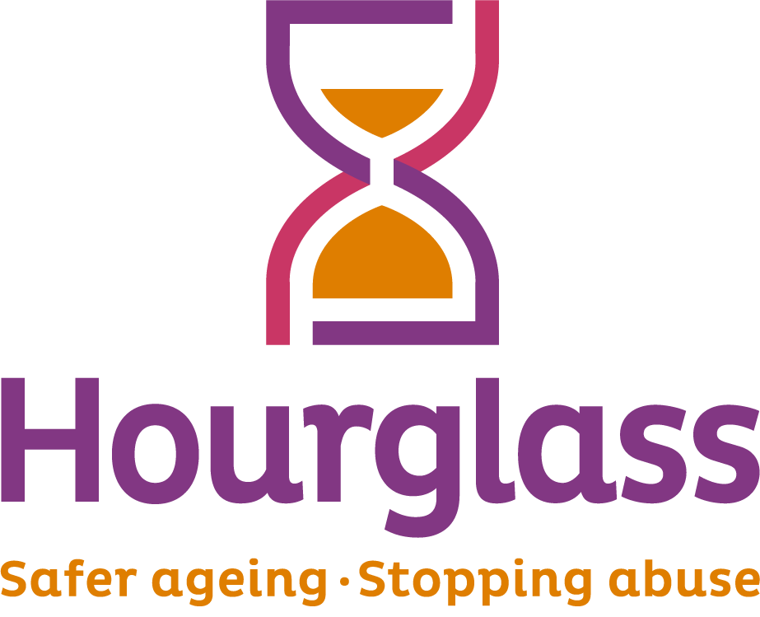
Job Description

Job title: | Information Officer (Central)
Location: | Can be based in any country. Posts in Scotland, Wales and Northern Ireland will be home-based initially, with an expectation of moving to an office location in due course. Posts in England will be based in our central London Office in due course.
Duration: | 1 year contract
Salary: | £20,600 per annum (35 hour per week)
Hours of work: | 35 hours (Monday to Friday, 9am – 5pm)
Reports to: | The post will be line managed by the Helpline Manager
Responsible for: | None. But will provide support to Helpline volunteers
Job Description last reviewed: | June 2020

1. CONTEXT AND PURPOSE OF JOB:

  - Hourglass is the only charity in the UK dedicated to calling time on the harm, abuse and exploitation of older people. We support older people experiencing, or at risk of, harm, abuse or exploitation, and work towards a fairer society for all older people.
  - We are seeing an Information Officer to provide information, advice and support on Hourglass’ well-established national Helpline. Working as part of a team of staff and volunteers across the UK, you will provide support to older people and others from all 4 nations. Providing information via telephone, email and other online methods, you’ll play a vital frontline role in providing immediate advice and support, as well as referring on to other sources of support and expertise.

2. MAJOR DUTIES AND RESPONSIBILITIES:

2.1 HELPLINE

2.1.1 To provide information, advice and support to older people relating to support options for older people experiencing (or at risk of abuse), and safer ageing. To provide accurate and appropriate information and support via telephone, email and other electronic methods, and assist callers to explore their options.

2.1.2 To provide practical and initial emotional support to service users, assessing the nature of each call/enquiry and responding in an empathetic and supportive manner. To ensure service users receive advice and support which is appropriate to their needs in a non-judgemental manner and which clearly identifies realistic and achievable options.

2.1.3 To explain safeguarding approaches to service users in a way that they can best understand, respecting their needs to receive as correct and as full information or advice as they are able to do, providing them with emotional support, and treating them with dignity and respect.

2.1.4 To make safeguarding referrals and liaise on behalf of service users who request or require such support, pursuing conclusions that are satisfactory to the service user.

2.1.5 To notify the Helpline Manager or a member of management of any circumstances in which there may be immediate risk to a caller and to take action as authorised.

2.1.6 To identify service users who may be willing to speak to the media, bringing these to the attention of the Helpline Manager or other member of the management team.

2.1.7 To undertake follow up contact with service users on a pre-determined basis to provide further support and/or ascertain outcomes; seeking contact details when possible.

2.1.8 To identify own needs for support, including emotional support, and use support services as needed. To attend and participate in training events as required.

2.1.9 To ensure the Helpline section is ready for operation at the commencement of shifts, and to provide support to volunteers where required.

2.2 INFORMATION

2.2.1 To assist in maintaining information resources, including briefing packs to be issued to service users. To inform the Helpline Manager of new information requirements.

2.2.2 To assist colleagues with the issuing of promotional material on conferences, seminars, fundraising, the Helpline and other services, as required.

2.2.3 To undertake research through telephone and internet to identify statutory, voluntary or other agencies or individuals who could receive information to publicise the helpline and other charity services, notifying the Helpline Manager of such gaps or opportunities, and supplying information.

2.2.4 To distribute follow-up information materials so Helpline service users via post, email or other electronic methods.

2.3 RECORD KEEPING AND INFORMATION SHARING

2.3.1 To maintain Helpline records using our Customer Relationship Management (CRM) database and other internal records.

2.3.2 To share relevant information relating to calls/enquiries with Helpline colleagues in line with organisational practice relating to data protection and confidentiality

2.4 GENERAL

2.4.1 In the absence of the Helpline Manager, to ensure Helpline volunteers are supported in line with organisational policy, including regular breaks during shifts, providing advice and support, and regular de-briefing.

2.4.2 To organise additional tasks for volunteers where appropriate.

2.4.3 To undertake administrative support as required.

2.4.4 To attend regular team meetings.

2.4.5 To travel as required.

PERSON SPECIFICATION:

ESSENTIAL CRITERIA:

1. At least one year’s experience, either formal or informal, in either Helpline work or another environment providing advice and support to clients; with demonstrable skills in call handling, listening and questioning.

2. An ability to listen constructively, analyse objectively, and provide advice and guidance in a non-judgemental manner.

3. An ability to work as part of a team, be flexible and adaptable according to changing needs, and work to deadlines;

4. An ability to liase and communicate effectively (both orally and in writing) and work collaboratively with colleagues and outside agencies;

5. An ability to constructively challenge and advocate on behalf of callers, identifying issues key to the individual circumstances, and pursuing matters to a satisfactory conclusion.

6. Able to manage own workload, cope with challenging or emotional callers, and be non-judgemental and empathetic

7. An ability to demonstrate a positive attitude to older people and a demonstrable interest in challenging elder abuse. An ability to deal appropriately with sensitive issues;

8. Numeracy and literacy sufficient to provide reports and observations, and maintain administrative records as required;

DESIRABLE CRITERIA:

- Understanding/experience of issues relating to older people, adult safeguarding, abuse, and/or health and social care.

- Direct experience of working with older people.

